-Activity PLUS Workshops 2017 –

When 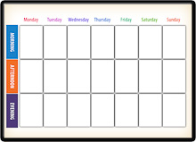 | - What   | - Where  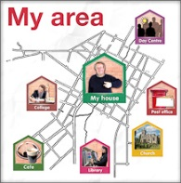 | - Cost per session  
- Monday  - 10:00am  - to  - 12noon | 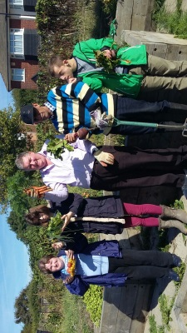  Allotment Croydon | Meet at the gates of the Spa Hill Allotment  Near Crystal Palace SE19. | £5  
Monday  - 10:00am  - to  - 12noon |   Arts and Crafts | PLUS offices  23 High Street, Penge,  London SE20 7HJ | £5
Monday  - 1:30 pm to  - 3:00pm |   Healthy Eating | PLUS offices  23 High Street, Penge,  London SE20 7HJ | £5
- Tuesday  - 10:00am  - to  - 12noon |   - Baking Workshop | Pretty Little Cupcakes  23 High Street, Penge,  London SE20 7HJ | £5
- Tuesday  - 1pm to 3pm | 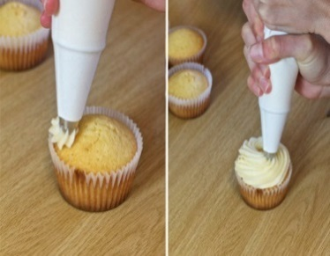  - Decorating Workshop | Pretty Little Cupcakes  23 High Street, Penge,  London SE20 7HJ | £5
- Wednesday  - 10:00am  - to  - 12 noon |   Art & Crafts | PLUS office  23 High Street, Penge,  London SE20 7HJ | £5
- Wednesday  - 1pm to 3pm |   IPAD Workshops | PLUS offices  23 High Street, Penge,  London SE20 7HJ | £5
- Wednesday  - 1pm to 3pm |   Allotment Grove Park | Meet at 12:30  At: Panorama Café. Belmont Hill.  Lewisham SE13 | £5
- Thursday  - 10:00am  - to  - 12noon | Baking Workshop | Pretty Little Cupcakes  23 High Street, Penge,  London SE20 7HJ | £5
- Thursday  - 1pm to 3pm | 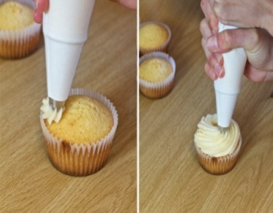  Decorating Workshop | Pretty Little Cupcakes  23 High Street, Penge,  London SE20 7HJ | - £5
- Thursday  - 1pm to 3pm | 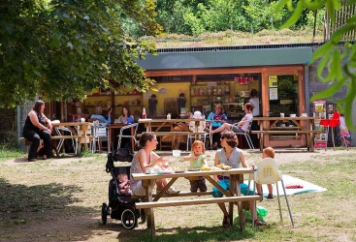  Wild Rovers  Men only | Meet at:  PLUS Office  6 Belmont Hill.  Lewisham  SE13 5BD | £5
- Friday  - 10:00am  - to 12noon | DROP –IN  Dance, paint, Domino & other games  see friends & a go at Bingo(50p a card) | PLUS Office  6 Belmont Hill  SE13 5BD | £3  
- Friday  - 1 pm to 2:30pm |   Bowling League | Meet at:  MFA Bowling  11-29 Belmont Hill,  SE13 5AU | 1 game: £3.50  
- Friday  - 1 pm to 2:30pm |  | Meet at:  MFA Bowling  11-29 Belmont Hill,  SE13 5AU | 2 games: £6
- Every Other Sunday  9:30am to 4:30pm  Must be booked & paid in advance | 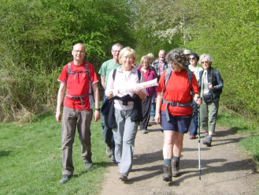  Rambling | Meet at:  PLUS Office  6 Belmont Hill.  Lewisham  SE13 5BD | £10 per person  



For more information contact Erika
At PLUS (Providence Lincs United Services)
On 0208 297 12 50 or
email erikav@plus-services.org

